# CS 255 System Design Document Template

## UML Diagrams

### UML Use Case Diagram

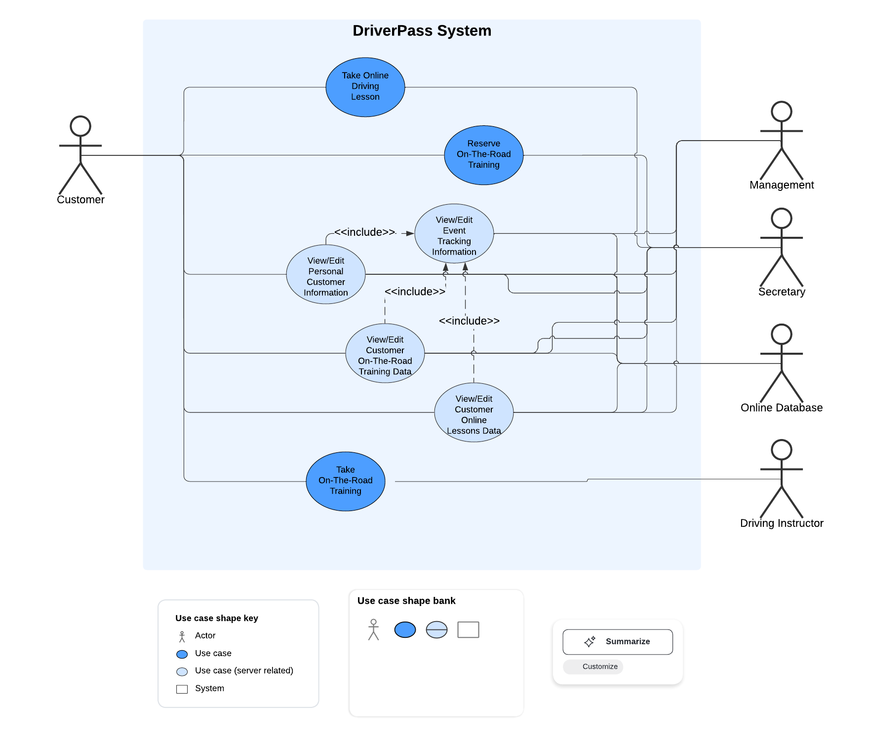

### UML Activity Diagrams

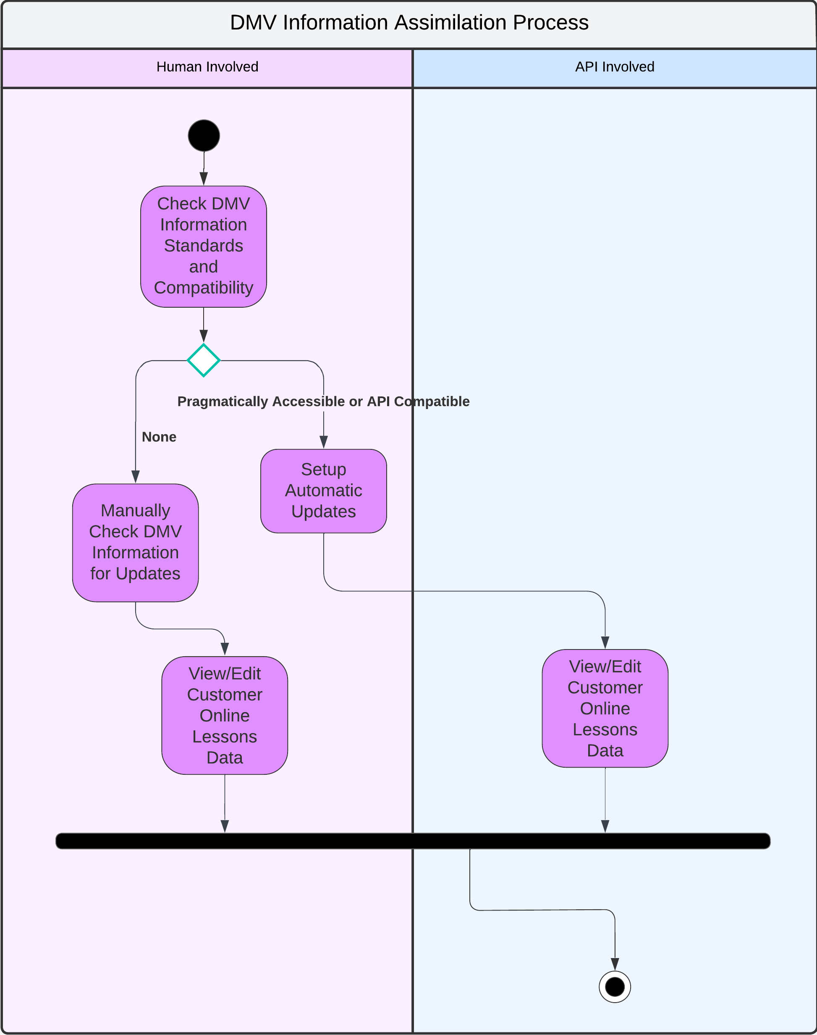

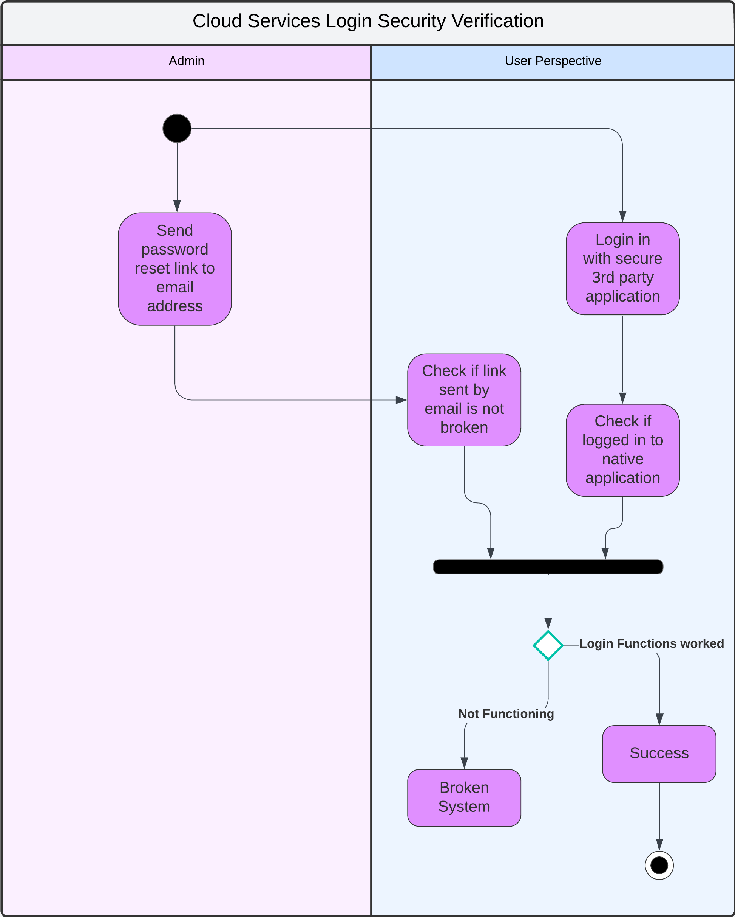

### UML Sequence Diagram

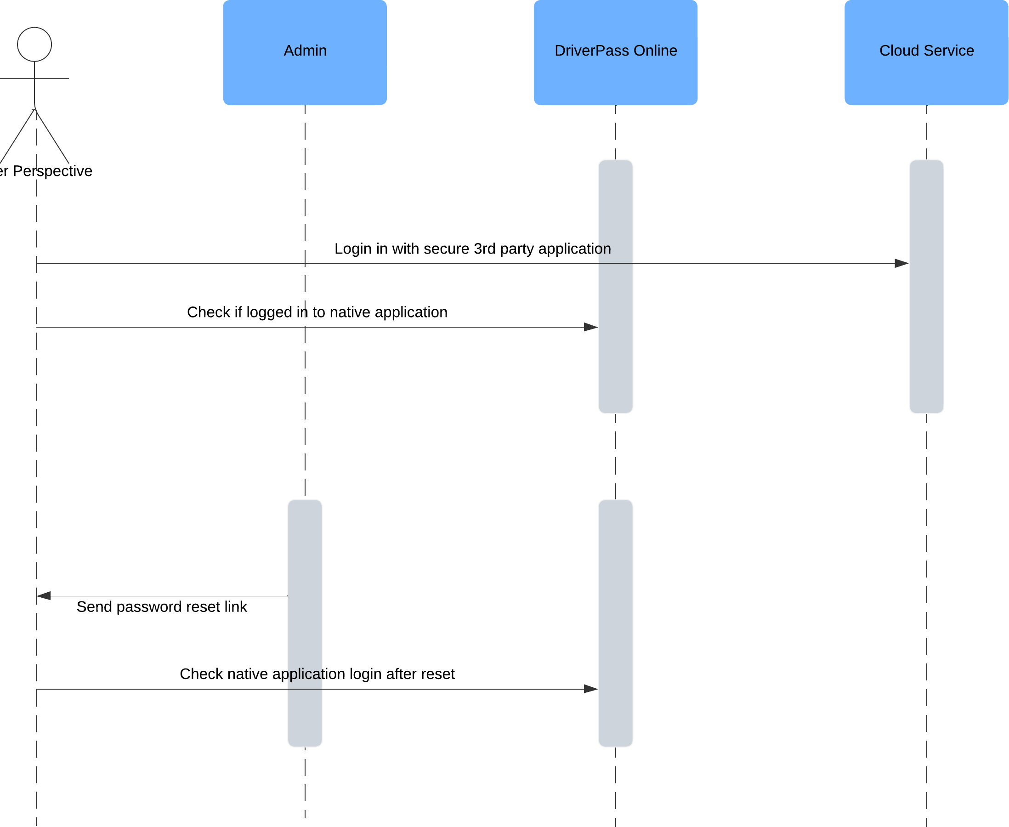

### UML Class Diagram

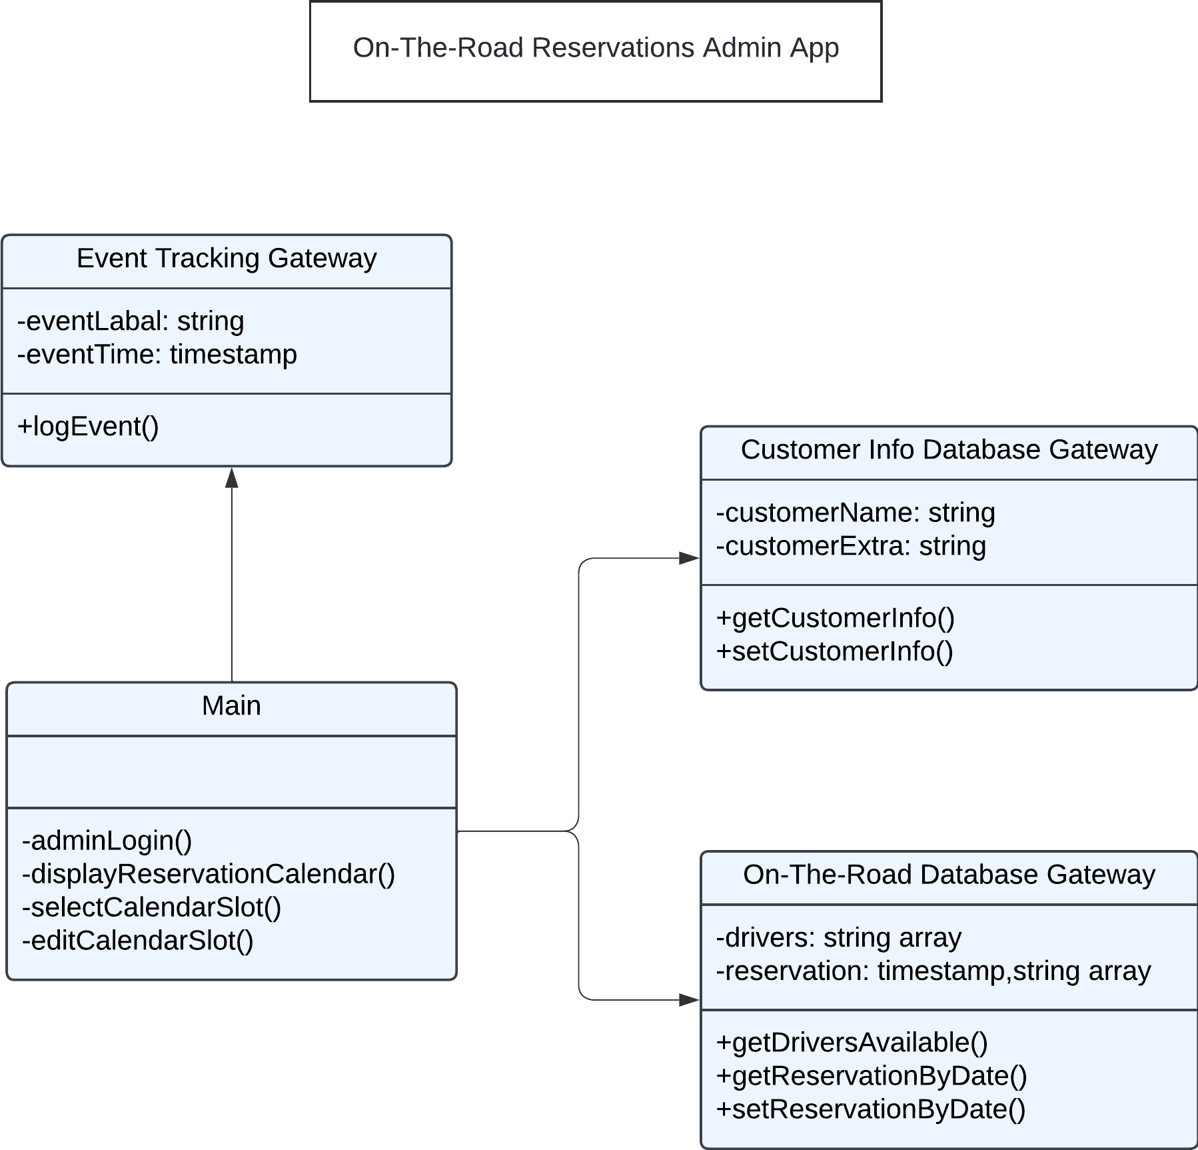

## Technical Requirements

*The DriverPass System requires cloud services and online servers. Three online databases act as the backbone for DriverPass. There are various applications (Example: On-The-Road Reservations Admin App) for different types of users which safely access and alter data on the databases. A cloud service is used to handle user personal information and can be appropriately accessed in each context via user ID. The system also allows automatic or manual update of DMV testing data for students taking online classes.*